TASK_PYTHON_SQL

NAME: SAMUEL

USN: 22BTRCL126

CSE-AI&ML-SEC-C

1. Create a database called as "Library" using SQL queries executed through MySQL workbench.

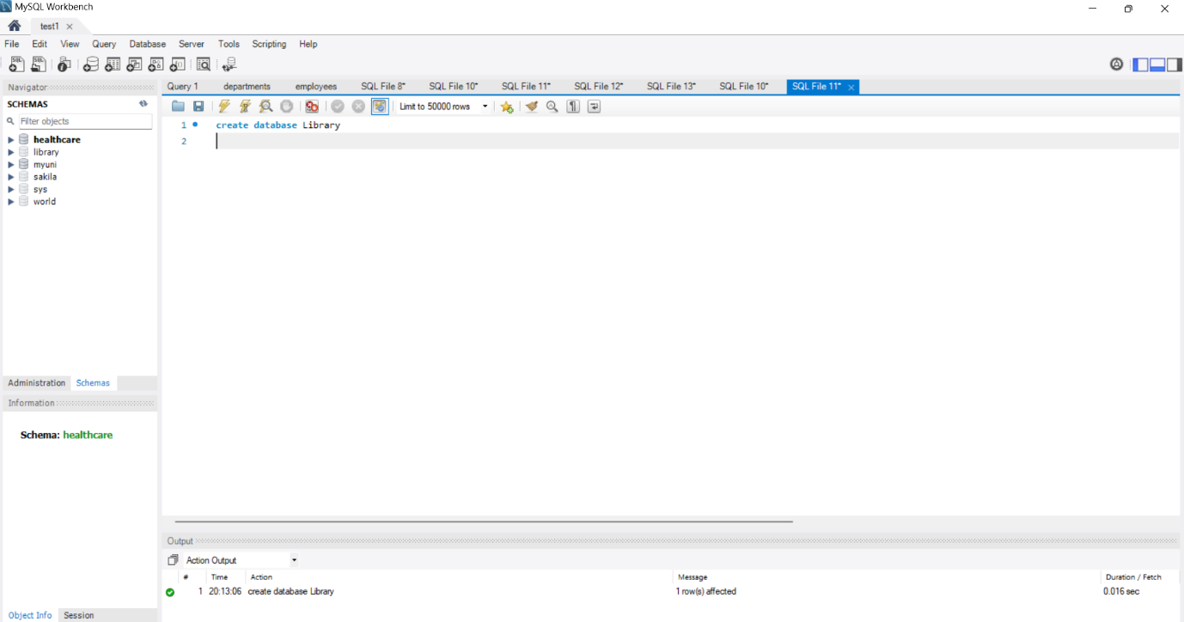

2. Create a table in this dataset called as "Books" using the same MySQL workbench, include following columns in this table:

a. bookID

b. bookName

c. USN

d. Author

e. price

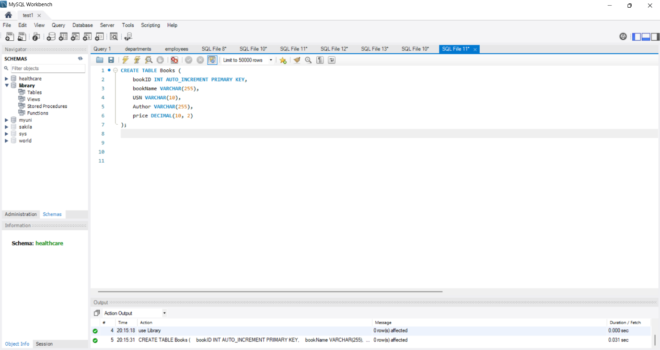

3. Insert at least 5 records in this table through SQL queries using MySQL workbench.

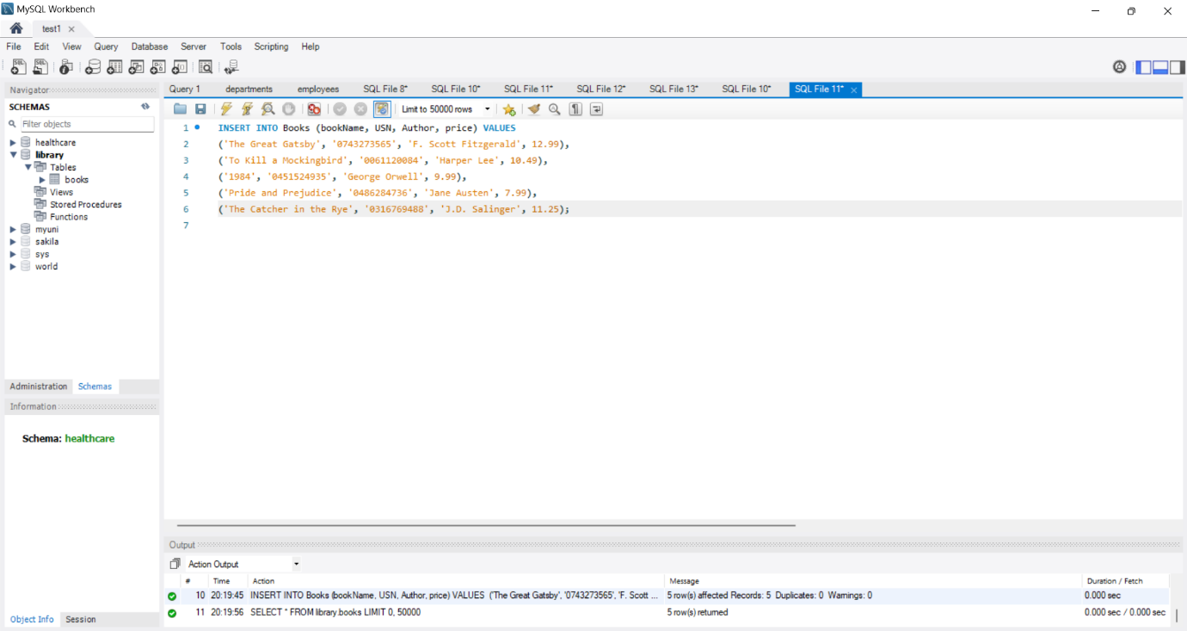

4. Write a python program that fetches all these data from this table directly through python program itself. Show the output on IDLE.

5. Write another python program that updates a record in this table directly through Python program. Show the output on IDLE.

6. Write another python program that deleted a record in this table directly through python program. Show the output on IDLE.

(You can also use one python program and execute these all tasks.). 